### **FRCPath Part 2—Revision Notes on *Aspergillus* spp.**

*(Oxford Textbook of Medical Mycology, Ch 10)*

#### **1. Genus at a glance**

* **> 200 species; > 30 human pathogens**—among the most ubiquitous environmental moulds; conidia inhaled daily.
* Characteristic **aspergillum** (asexual conidial head); despite known teleomorphs, the 2012 “one-fungus-one-name” rule retains *Aspergillus* nomenclature .
* **Commercial uses:** *A. niger* → citric-acid & enzyme production; *A. oryzae* → sake/soy fermentation .

#### **2. Aspergillus Key species, temperatures, toxins & clinical points**

|  |  |  |  |  |
| --- | --- | --- | --- | --- |
| **Species (complex)** | **Opt. Temp / Range (°C)** | **Colony / Microscopy** | **Major toxin** | **Salient clinical facts** |
| *A. fumigatus* | 37 / 12-65 | Green-blue; columnar uniseriate heads | — | **Commonest invasive isolate**; ABPA, CPA |
| *A. flavus* | 37 / 12-48 | Green-yellow; radiate uni/bi-seriate | **Aflatoxin** | Sinusitis, keratitis, aflatoxicosis risk |
| *A. niger* | 37 | Black biseriate heads | — | Otomycosis, onychomycosis |
| *A. terreus* | 25-40 | Beige; biseriate + **accessory conidia** | **Ochratoxin** | Intrinsic AmB-R |
| *A. nidulans* | 37 / 2-48 | Green with red-brown cleistothecia | — | CGD infections; AmB-R |
| *A. versicolor* | 22-26 (opt); ≤40 | White→yellow/green; penicillium-like | **Sterigmatocystin** | Onychomycosis; grows best at room-temp |
| *A. clavatus* | 37 | Long club-shaped vesicle | — | **Extrinsic allergic alveolitis** (“malt-worker’s lung”) |

***EORTC definitions***

Proven:

* Histologically proven and evidence of tissue damage
* Growth of aspergillus from a sterile site

Probable

* Host factor: neutropenia, transplant, cirrhosis, HIV, chronic lung disease, steroids, infleunza pneumonitis
* Presence in the lower respiratory tract: cytology, microscopy or growth OR GM >0.8 in BALF, >0.5 in serum
* Radiological factors: nodule, air crescent, cavity, wedge/segmental/lobar consolidation, tracehobrachial eschar or ulcer.

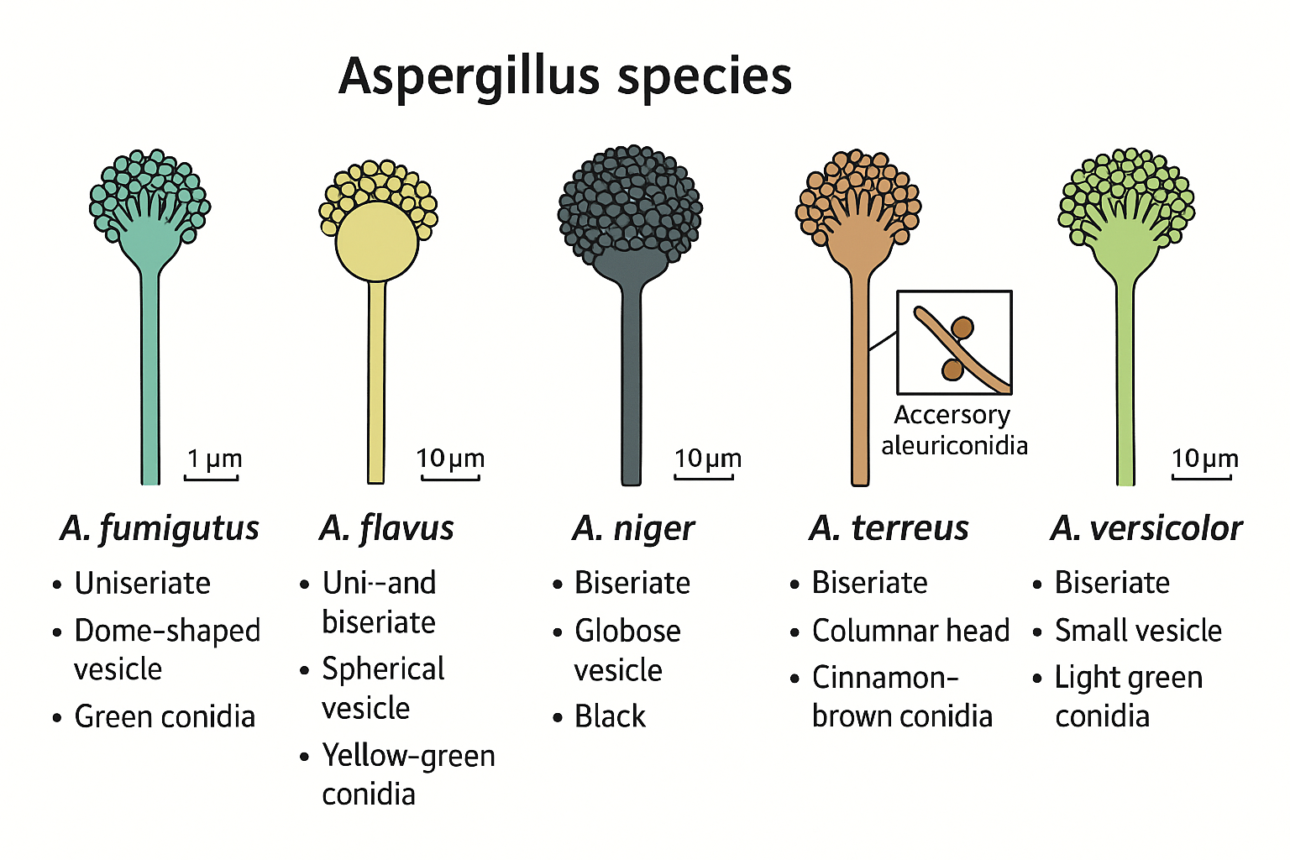

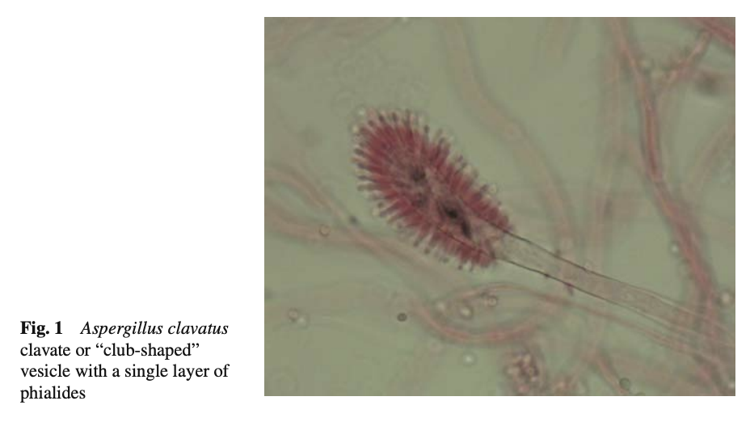

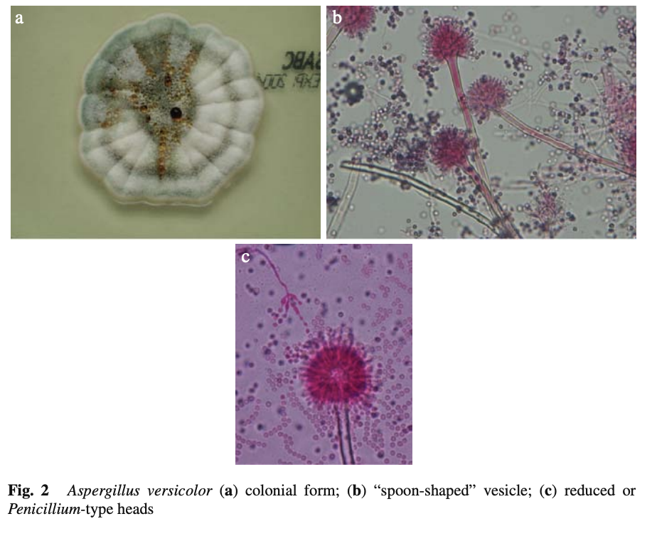

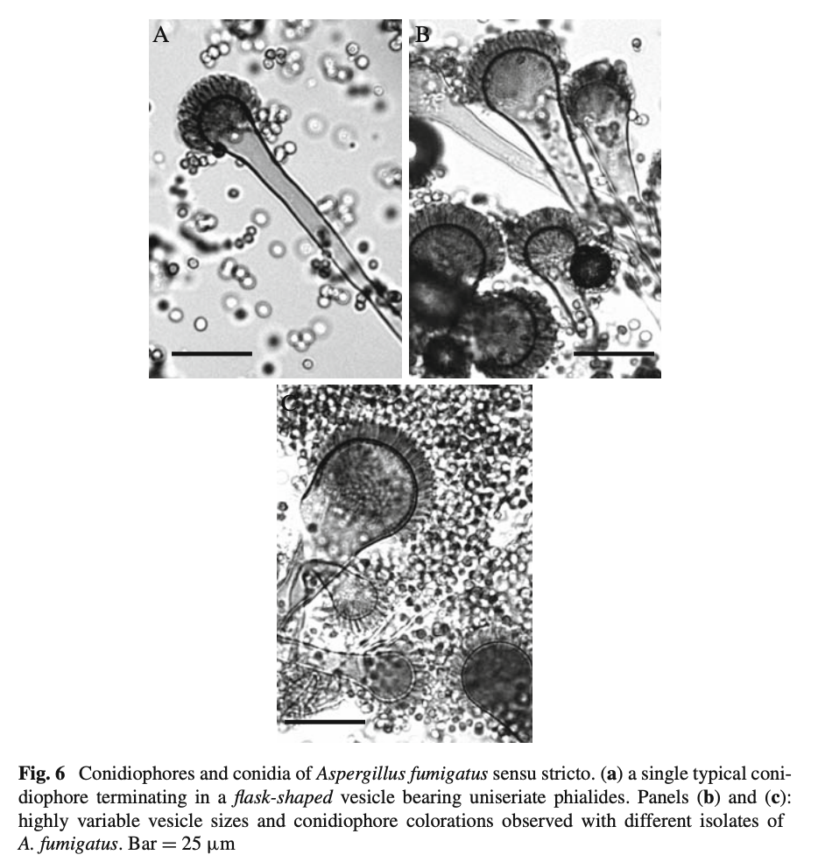

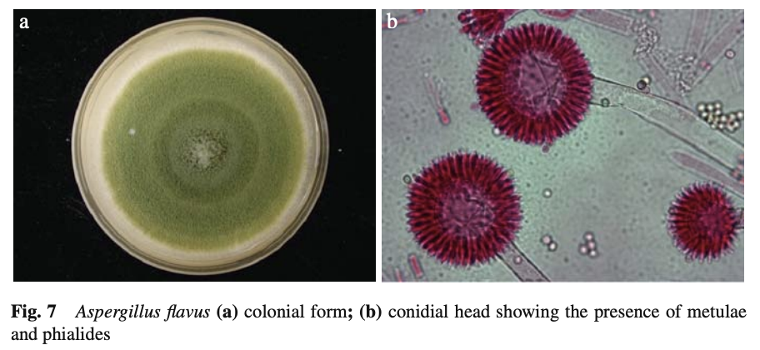

Green-yellow radiate, compare to A. fumigatus

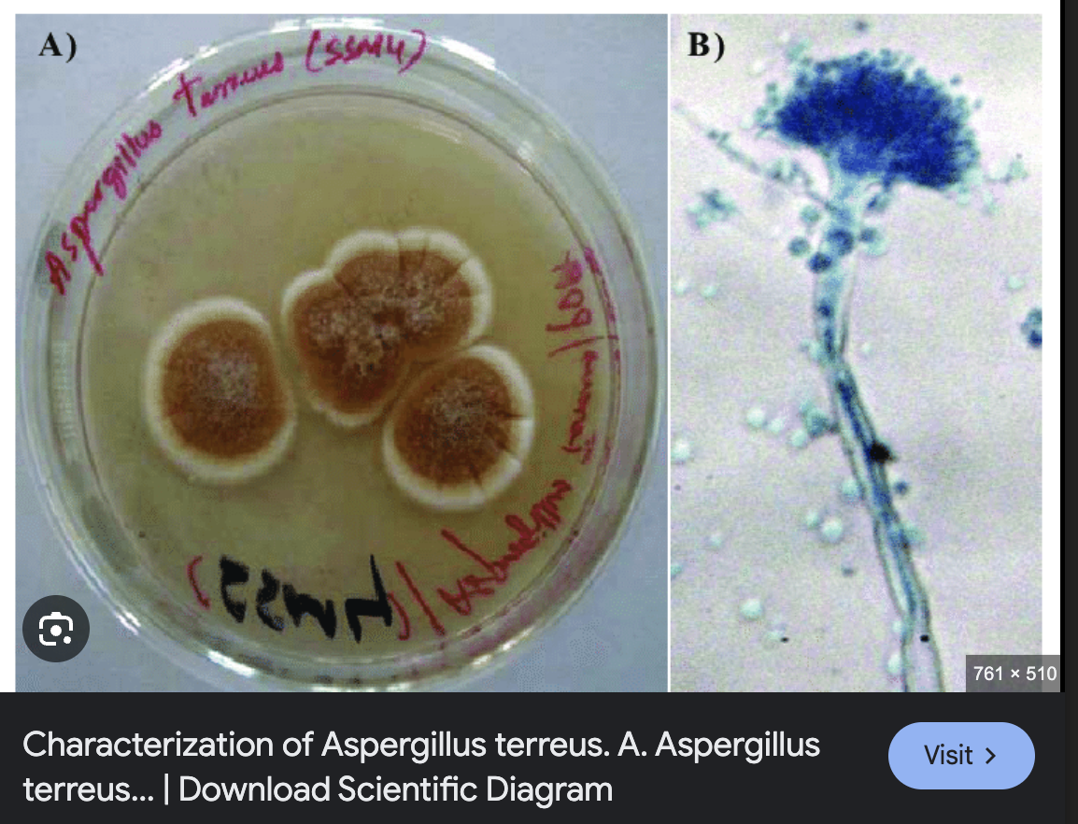

Cinnamon colored, columnar

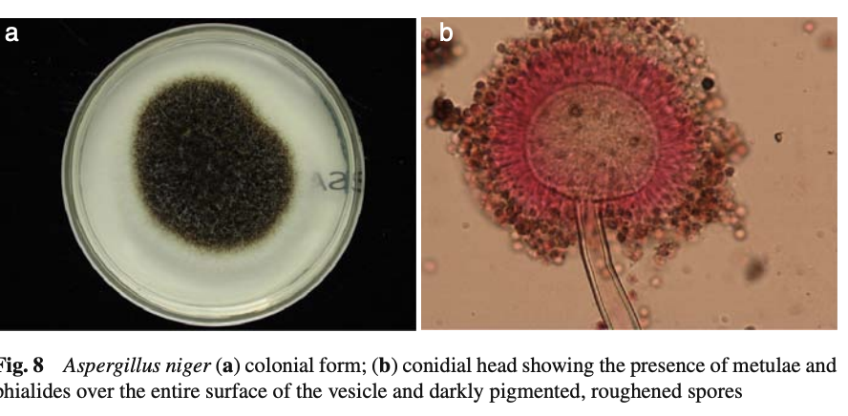

#### **3. Epidemiology & reservoirs**

* Conidia in **soil, rotting vegetation, damp building materials (wallpaper, concrete, pipe-lagging, carpets, HVAC)**; hospital construction dust → outbreaks .
* **High-risk hosts:** prolonged neutropenia, allogeneic-HSCT (~12 %), heart-lung Tx (11 %), CGD, high-dose steroids .
* **CPA** rising after TB, COPD, sarcoidosis .

#### **4. Pathogenesis (4-step mnemonic I-G-A-T)**

1 **I**nhalation & alveolar deposition

2 **G**ermination when innate immunity fails

3 **A**ngio-invasion → thrombosis, infarction

4 **T**oxins & hypersensitivity drive allergic / chronic disease

#### **5. Clinical spectrum**

|  |  |
| --- | --- |
| **Category** | **Typical entities / notes** |
| **Non-invasive** | Otomycosis (*A. niger*), onychomycosis (*A. versicolor*), allergic fungal rhinosinusitis |
| **Allergic** | **ABPA** (≈16 % asthmatics); **EAA** by *A. clavatus*; SAFS |
| **Chronic** | **CPA** continuum: simple aspergilloma → chronic cavitary → fibrosing disease |
| **Invasive** | Acute pulmonary IA ± CNS, eye, skin; sinusitis; mortality 50–85 % |

#### **6. Diagnosis workflow**

1. **Direct / culture:** septate 45° branching hyphae; Sabouraud agar 48-90 h.
2. **Serology & biomarkers:**
   1. **Aspergillus precipitins (IgG)**—best single test for CPA/ABPA support .
   2. Galactomannan ELISA / LFD (false-pos with β-lactams) .
   3. (1→3) β-D-glucan (pan-fungal) .
   4. PCR on blood/BAL; combine with GM for ↑ sensitivity .
3. **Imaging:** HR-CT halo sign → air-crescent; MRI for CNS/sinus.
4. **Histology/BAL/biopsy** for EORTC “proven” disease.

#### **7. Antifungal susceptibility & resistance**

* **Azole-R *A. fumigatus*** increasing in Europe (environmental TR34/L98H, TR46/Y121F/T289A).
* **Intrinsic AmB-R:** *A. terreus*, *A. nidulans*.
* Always request MICs on invasive isolates.

#### **8. Management cheat-sheet**

|  |  |  |
| --- | --- | --- |
| **Condition** | **First-line** | **Key alternatives / notes** |
| Invasive aspergillosis | **Voriconazole** | Liposomal AmB; isavuconazole (non-inferior; shortens QT c) |
| ABPA | Oral steroids ± itraconazole/posaconazole |  |
| CPA | Long-term oral triazole; monitor levels |  |
| Onychomycosis / Otomycosis | Topical clotrimazole ± oral azole |  |
| Surgical | Resection of solitary aspergilloma; debridement of sinus/CNS masses |  |

Supportive: remove colonised lines, taper immunosuppression, give G-CSF if neutropenic.

#### **9. Prognosis & prevention**

* IA mortality: 50-60 % (SOT) → 70-85 % (other immunosuppressed). Early targeted therapy improves survival .
* **Primary prophylaxis** (e.g. posaconazole in AML/allo-HSCT) cuts incidence but monitor for resistance.
* **Environmental control:** HEPA filtration, positive-pressure rooms, meticulous dust containment during building/refurbishment .

#### **10. High-yield exam pearls**

1. Columnar uniseriate head **+ growth to 65 °C = *A. fumigatus***.
2. **Accessory conidia** → think *A. terreus* (and AmB-R).
3. Galactomannan **false-positive** with piperacillin-tazobactam or *Penicillium*.
4. **Sterigmatocystin ↔ *A. versicolor***; **ochratoxin ↔ *A. terreus***; **aflatoxin ↔ *A. flavus***.
5. Report isolates as “*A. fumigatus* complex” unless molecular ID performed (≥ 40 cryptic species) .
6. **Isavuconazole** shortens QTc (contrast other azoles).
7. Memorise **EORTC/MSG 2008** possible/probable/proven definitions—frequent SAQ.
8. **Environmental reservoirs** (damp concrete, carpets, HVAC) explain hospital outbreak questions.
9. Room-temperature growth (~25 °C) onychomycosis isolate? Think *A. versicolor*.